Project Title: NetPath Illuminator – The Network Odyssey

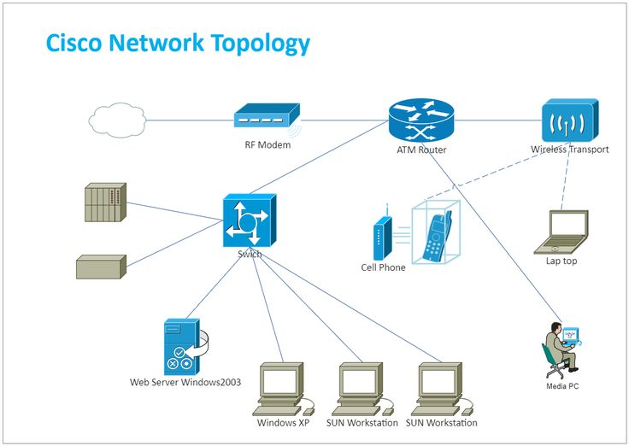

**Submitted By:**

Student Name: Kaviya M

Register No: 923322106019

Branch: Electronics and Communication Engineering

Email id: kaviyamahadev@gmail.com

College Name: Government College of Engineering, Bodinayakanur

AICTE ID:1-2181710931

# LEVEL 1: Direct PC to PC Communication

## Objective:

To establish a basic network between two PCs and study ARP (Address Resolution Protocol), MAC & IP addressing.

## Topology Used:

* PC0 ↔ PC1 (via copper cross cable)

## IP Configuration:

* PC0: 10.1.1.1 /8
* PC1: 10.1.1.2 /8

## Commands Used:

* ping 10.1.1.2
* arp -a
* arp -d
* ipconfig

## Observations:

* Ping successful.
* ARP table shows IP–MAC mapping.
* After arp -d, cache is cleared and repopulated on next ping.

## Flow Diagram:

## Commands Captured:

## Conclusion:

Learned how ARP resolves IP to MAC. Understood the role of IP and MAC addresses in direct communication.

# LEVEL 2: PC to PC via Switch

## Objective:

To connect multiple PCs using a switch and understand MAC address learning.

## Topology Used:

* PC0, PC1, PC2, PC3 ↔ Switch0

## IP Configuration:

* PC0: 10.1.1.1 /8
* PC1: 10.1.1.2 /8
* PC2: 10.1.1.3 /8
* PC3: 10.1.1.4 /8

## Commands Used:

* ping 10.1.1.2
* arp -a

In Switch0

* show mac address-table

## Observations:

* Switch learns MAC addresses dynamically.
* Verified MAC entries and port mappings.
* Learned about flooding and forwarding.

## Flow Diagram:

## Commands Captured:

Conclusion:

Switching works at Layer 2 using MAC. Learned how switches build MAC address tables.

# LEVEL 3: PC to PC (Different Subnets, No Router)

## Objective:

To understand failed communication due to subnet mismatch.

## Topology Used:

* PC0 ↔ PC1 (via copper cross cable)

## IP Configuration:

* PC0: 10.1.1.1 /8
* PC1: 20.1.1.1 /8

## Commands Used:

* ping 20.1.1.1
* arp -a

## Observation:

* Ping fails.
* ARP entry not created.
* ARP broadcasts do not cross subnets.

## Flow Diagram:

## Commands Captured:

Conclusion:

Router is needed for communication across different subnets.

# LEVEL 4: PC to PC via Router

## Objective:

Enable inter-subnet communication using a router.

## Topology Used:

* PC0↔ Router ↔ PC1

## IP Configuration:

* PC0: 10.1.1.10 /8
* Router: Interfaces for both subnets
* PC1: 20.1.1.10 /8

## Commands Used:

* ping
* show ip route
* show ip interface brief

## Observation:

* Ping successful.
* Routing table shows connected networks.
* Default gateway plays a vital role.

## Flow Diagram:

## Commands Captured:

* Ping Test: From PC0 to PC1

* From Router0

Conclusion:

Router connects different subnets using Layer 3 routing.

# LEVEL 5: Router + Switch + Multiple PCs

## Objective:

Test routing between two networks with switch and router

## Topology Used:

* Multiple PCs ↔ Switch ↔ Router ↔ Other Switch ↔ Other PCs.

## IP Configuration:

Network 1

* PC0: 192.168.1.10 /24
* PC1: 192.168.1.11 /24
* PC2: 192.168.1.12/24
* Default Gateway: 192.168.1.1

Network 2

* PC0: 192.168.2.10 /24
* PC1: 192.168.2.11 /24
* PC2: 192.168.2.12/24
* Default Gateway: 192.168.2.1

## Commands Used:

* ping from PC0 to PC5
* show ip route
* show ip arp
* show mac address-table

## Observation:

* Verified inter-network routing.
* Observed ARP table and MAC learning.

## Flow Diagram:

## Commands Captured:

* Ping Test: From PC0 to PC5

* From Router0

* From Switch0

Conclusion:

Understood full Layer 2 & Layer 3 behaviour in a mixed network.

# Level 6 – Static Routing

Objective:  
Enable network communication via manually configured static routes.

## Topology Used:

* PC’s ↔ Switch0 ↔ Router0↔ Router1 ↔ Router2 ↔ Switch1↔ PC’s

## Commands Used:

* ip route <destination> <mask> <next-hop>
* show ip route
* show running-config

## Observations:

* Ping successful after static route added.
* Routing table updated manually.

## Flow Diagram:

## Commands Captured:

* Ping Test: From PC0 to PC5

* From Router0

* From Switch0

* From Switch1

Conclusion:

Static routing is manual but effective for small networks.

# Level 7 – Dynamic Routing using OSPF

Objective:  
Enable automatic route discovery using OSPF.

## Topology Used:

* PC’s ↔ Switch0 ↔ Router0↔ Router1 ↔ Router2 ↔ Switch1↔ PC’s.

## Commands Used:

* router ospf 1
* network <ip> <wildcard> area 0
* show ip route

## Observations:

* OSPF dynamically builds routing table.
* Routers exchange routing info.

## Flow Diagram:

## Commands Used:

* Ping Test: From PC0 to PC3

* From Router0

Conclusion:  
Dynamic routing like OSPF is scalable and efficient.

# Level 8 – OSPF with Primary and Backup Path

Objective:  
Observe dynamic path switching using OSPF upon link failure.

## Topology Used:

* Routers with primary and secondary paths to server

## Commands Used:

* show ip route
* tracert <PC2 ip_address>
* interface Fa0/1 → shutdown
* show ip ospf neighbor
* show ip ospf interface brief

## Observations:

* Before shutdown: packets use primary path
* After shutdown: OSPF reroutes traffic via backup
* Convergence delay observed.

## Flow Diagram:

## Commands Captured:

* From PC0 to PC2

* From Router1:

Conclusion:  
OSPF dynamically adjusts to topology changes, ensuring fault tolerance.

# .pkt Files

* 1. [LEVEL1 - Direct PC to PC Communication](D:\\Cisco Projects\\level1.pkt)
  2. LEVEL 2: PC to PC via Switch
  3. LEVEL 3: PC to PC (Different Subnets, No Router)
  4. LEVEL 4: PC to PC via Router
  5. LEVEL 5: Router + Switch + Multiple PCs
  6. LEVEL 6 – Static Routing
  7. LEVEL 7 – Dynamic Routing using OSPF
  8. LEVEL 8 – OSPF with Primary and Backup Path